**Step 1: Drawing Basic Shapes With Python Turtle**

1. Create an new Repl by selecting the **“Python with Turtle”** language / environment.

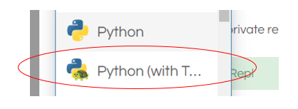

1. Begin all of your turtle programs with the following code to create a “pen”:

import turtle

myPen = turtle.Turtle()

1. Review the following chart for a list of Turtle commands.

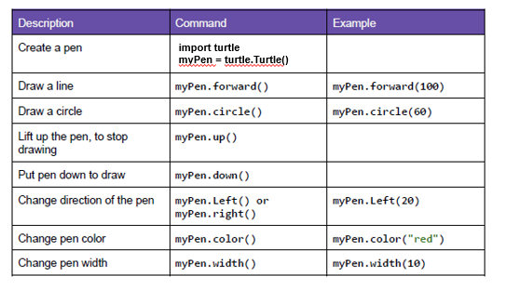

1. Use the following program to draw a red square.

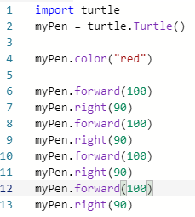

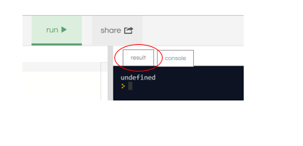

1. Switch to the “Result” window to see the square.
2. Create a program to draw any one of the shapes “b”, ”d”, or “e” shown in the figures below.   
   Provide a listing of your program code.

import turtle

myPen = turtle.Turtle()

myPen.color("black")

myPen.forward(100)

myPen.right(90)

myPen.forward(50)

myPen.right(90)

myPen.forward(100)

myPen.right(270)

myPen.forward(100)

myPen.right(90)

myPen.forward(50)

myPen.right(90)

myPen.forward(100)

myPen.right(270)

myPen.forward(100)

myPen.right(90)

myPen.forward(50)

myPen.right(90)

myPen.forward(100)

myPen.right(270)

myPen.forward(100)

myPen.right(90)

myPen.forward(50)

myPen.right(90)

myPen.forward(100)

myPen.right(270)

1. Create a program to draw any one of the shapes “c”, or “f” shown in the figures below.   
   Provide a listing of your program code.

c)

import turtle

myPen = turtle.Turtle()

myPen.color("red")

myPen.forward(100)

myPen.right(90)

myPen.forward(100)

myPen.right(90)

myPen.forward(100)

myPen.right(90)

myPen.forward(100)

myPen.right(90)

myPen.up

myPen.right(90)

myPen.forward(50)

myPen.down

myPen.color("blue")

myPen.circle(50,360)

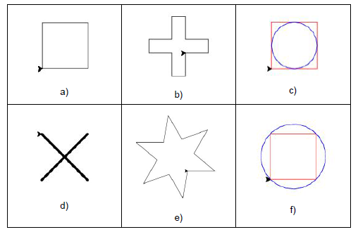

**Step 2: Christmas / Winter Theme Card**

1. Use your creativity to create a card design using Turtle.
   1. The design must have multiple figures.
   2. The design must have at least two different patterns.
   3. You may repeat patterns.
   4. Provide a listing of your program code.
   5. Provide an image of your program result.

import turtle

backGround=turtle.Screen()

backGround.bgcolor("red")

tree = turtle.Turtle()

tree.speed(5)

tree.penup()

tree.goto(0,0)

tree.color("green")

tree.begin_fill()

tree.fillcolor("green")

tree.pensize(8)

tree.pendown()

tree.goto(100,0)

tree.penup()

tree.end_fill()

tree.goto(100,0)

tree.pendown()

tree.color("green")

tree.begin_fill()

tree.fillcolor("green")

tree.goto(0,75)

tree.goto(-100,0)

tree.forward(100)

tree.goto(125,-65)

tree.goto(-125,-65)

tree.goto(0,0)

tree.penup()

tree.end_fill()

tree.goto(0,75)

tree.pendown()

tree.color("green")

tree.begin_fill()

tree.fillcolor("green")

tree.goto(50,75)

tree.goto(0,120)

tree.goto(-50,75)

tree.goto(0,75)

tree.penup()

tree.end_fill()

tree.goto(0,-90)

tree.pendown()

tree.color("brown")

tree.begin_fill()

tree.fillcolor("brown")

tree.goto(20,-90)

tree.left(90)

tree.forward(20)

tree.left(90)

tree.forward(40)

tree.left(90)

tree.forward(20)

tree.left(90)

tree.forward(20)

tree.penup()

tree.end_fill()

def write_message(turtle, color, x, y):

turtle.penup()

turtle.goto(x,y)

turtle.pendown()

turtle.pensize(8)

turtle.color(color)

turtle.write("Merry Christmas Mr. Nestor!!", None, None, "16pt bold")

write_message(turtle, "blue", -120,-150)

write_message(tuple, "yellow", 75, -50)

write_message(turtle, "blue", -175, 0)

